Prepared By: | Document Title | Version | Date
Mohan Mudaliar | SOP for Applying Oracle NON-ASM database patches(RU/PSU/CPU/one-off) | 1.0 | April 13/2026

1. Document Information
Item | Details
Database Type | Standalone (Non-RAC)(Non-ASM)
Oracle Version | Applicable to 11g / 12c / 18c / 19c
Patch Type | RU / PSU / CPU / One-Off
Executed By | DBA
Environment | Dev / Test / Prod

2. Purpose
To safely apply Oracle database patches (RU / PSU / CPU / one-off) with minimal risk, ensuring rollback capability and system stability.

3.Transfer Patches
We have placed patches in haluxtstoms01 server. Transfer below patches from below location to the Target server.
Location:
(haluxtstoms01) > pwd
/software/RU_JAN_2026
(haluxtstoms01) > ls -lrt
total 2772473
-rwxrwxrwx. 1 oracle dba 2410657736 Mar 23 08:19 p38658587_190000_Linux-x86-64.zip
-rwxrwxrwx. 1 oracle dba 72896144 Apr 7 08:20 p6880880_190000_Linux-x86-64.zip

3.1 Got to Target server and run below command.

mkdir -p /dbusr/patches
mkdir -p /dbusr/patches/DBRU
mkdir -p /dbusr/patches/OJVM

3.2 Go to haluxtstoms01 server.
Use SFTP or RSYNC to transfer the patches

sftp oracle@<target hostname>
mput /software/RU_JAN_2026/*.zip /dbusr/patches/

OR
rsync -aP /software/RU_JAN_2026/*.zip oracle@<target hostname>:/dbusr/patches/

4. Pre-Patch Activities (Pre-QA Checklist)
4.1 Confirm Oracle Environment
echo $ORACLE_HOME
echo $ORACLE_SID
sqlplus -v

Verify inventory pointer:
cat /etc/oraInst.loc

4.2 Verify OPatch Version
$ORACLE_HOME/OPatch/opatch version
✅ Ensure OPatch version matches the patch README requirement.

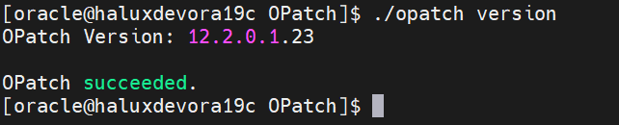

4.3 Check /dbusr , /tmp mountpoints
Check these mount points (/dbusr , /tmp ) its utilization should be below 60%.

4.4 Pre-QA: Database Status Verification
Instance & Database Status

set echo on
set feed on
set timing on
set time on
set lines 200 pages 2000
col INSTANCE_NAME for a20
col VERSION for a15
col OPEN_MODE for a20
col DATABASE_ROLE for a20
col HOST_NAME for a30
SELECT INSTANCE_NAME,HOST_NAME,VERSION,open_mode,database_role,controlfile_type,STARTUP_TIME FROM v$database,v$instance;

go to sqlplus prompt to Run preqa.sql
Sqlplus / as sysdba
Spool <ctask>preqa.log
@dbpreqa.sql – and press enter key
Spool off

4.5 Pre-QA: Invalid Object Count
set lines 200
col owner for a20
col object_name for a30
col object_type for a20

SELECT COUNT(*) AS invalid_objects
FROM dba_objects
WHERE status = 'INVALID';

select owner,object_name,object_type,status from dba_objects where status='INVALID' order by 1,3,2;

✅ Record count for post-patch comparison.

4.6 Pre-QA: DBA Registry Components
SELECT comp_name, status, version
FROM dba_registry;

Expected status:
- All components should be VALID

4.7 Pre-QA: DBA_REGISTRY_SQLPATCH
SELECT patch_id, action, status, action_time
FROM dba_registry_sqlpatch
ORDER BY action_time;

✅ Capture current patch level.

5. Backup Activities (Mandatory)
5.1 Database Backup (RMAN)
Check if we have latest and successful backup.(You can also check with Backup Team)

Set line 2000
col end_time for a20
col start_time for a20
col time_taken_display for a20
select SESSION_KEY, INPUT_TYPE, STATUS,
to_char(START_TIME,'mm/dd/yy hh24:mi') start_time,
to_char(END_TIME,'mm/dd/yy hh24:mi') end_time,
time_taken_display,
input_bytes/1024/1024/1024,
output_bytes/1024/1024/1024
from V$RMAN_BACKUP_JOB_DETAILS
where INPUT_TYPE='ARCHIVELOG' and STATUS='COMPLETED'
order by to_date(end_time,'mm/dd/yy hh24:mi') asc ;

5.2 Parameter file backup.

Create pfile from spfile.

5.3 Opatch backup.

cd $ORACLE_HOME/OPatch
mv OPatch OPatch_ddmmyy

✅ All backups must be validated before proceeding.

6. Patch Implementation Steps
6.1 Unzip Patch
export SOFTWARE_DIR=/dbusr/patches
export OPATCH_FILE="p6880880_190000_Linux-x86-64.zip"
export PATCH_FILE1="p38658587_190000_Linux-x86-64.zip"
export PATCH_TOP=${SOFTWARE_DIR}
export PATCH_PATH1=${PATCH_TOP}/DBRU/38658587/38632161
export PATCH_PATH2=${PATCH_TOP}/OJVM/38523609

# Unzip patches.
cd $ORACLE_HOME
cp ${SOFTWARE_DIR}/${OPATCH_FILE} $ORACLE_HOME
unzip ${OPATCH_FILE}
cd ${SOFTWARE_DIR}/DBRU
unzip -oq ${PATCH_FILE1}

cd ${SOFTWARE_DIR}/DBRU/38658587
mv 38523609 ${SOFTWARE_DIR}/OJVM/

6.2 Stop Database & Listener

sqlplus / as sysdba
SHUTDOWN IMMEDIATE;
EXIT;

lsnrctl stop <listener name>
6.3 Oracle Home Backup

cd /
tar -cvf /dbxdining/oracle_home_$(date +%F).tar $ORACLE_HOME

6.4 Oracle Inventory Backup

cp -r /dbusr/app/oraInventory /dbxdining/oraInventory_$(date +%F)

6.5 Check Patch Conflicts (DBRU)

cd ${PATCH_PATH1}
$ORACLE_HOME/OPatch/opatch prereq CheckConflictAgainstOHWithDetail -ph ./
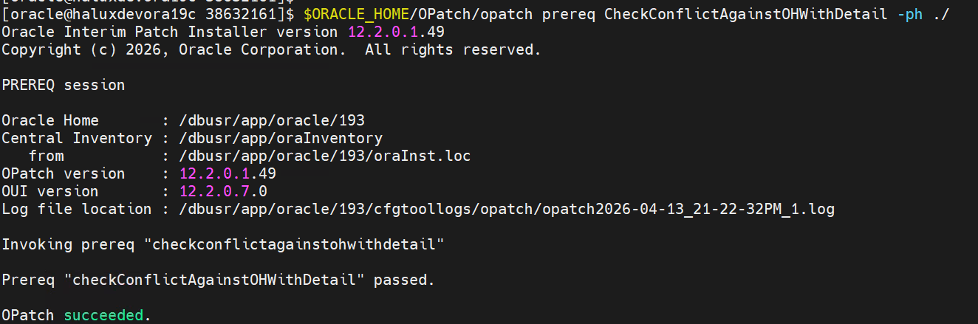
6.6 Apply Patch to Oracle Home (DBRU)

$ORACLE_HOME/OPatch/opatch apply
✔ Confirm:
OPatch succeeded.
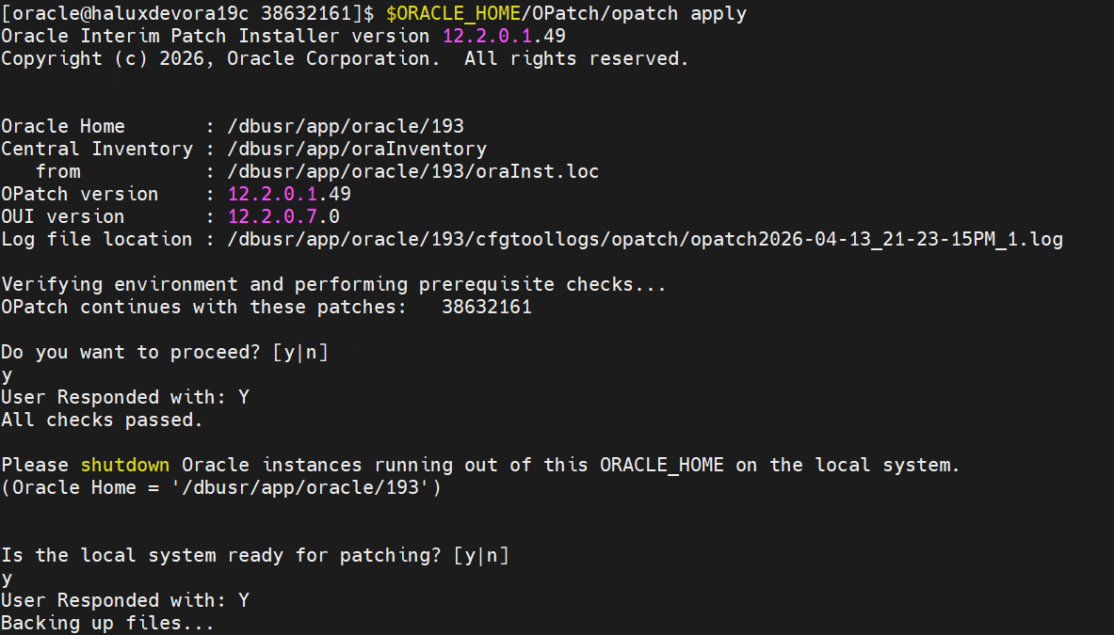
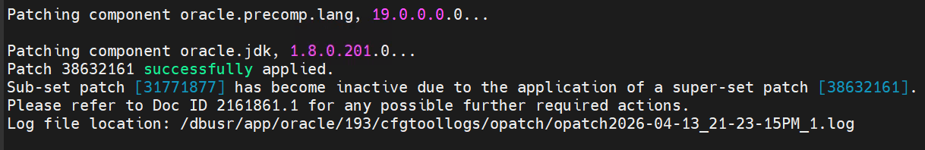
6.7 Check Patch Conflicts (OJVM)
cd ${PATCH_PATH2}
$ORACLE_HOME/OPatch/opatch prereq CheckConflictAgainstOHWithDetail -ph ./
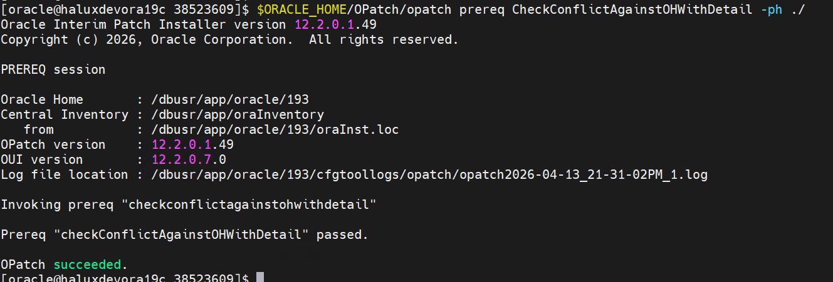
6.8 Apply Patch to Oracle Home (OJVM)
$ORACLE_HOME/OPatch/opatch apply
✔ Confirm:
OPatch succeeded.
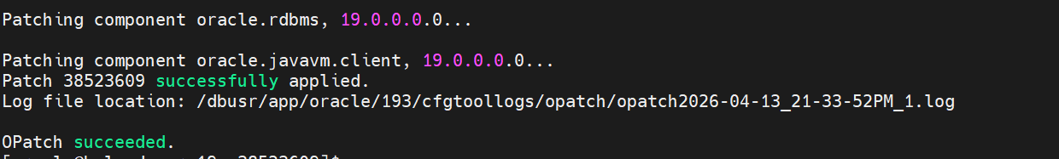

6.9 Verify Oracle Home Inventory
cd $ORACLE_HOME
opatch lsinventory
opatch lspatches
✅ Ensure patch ID is listed.
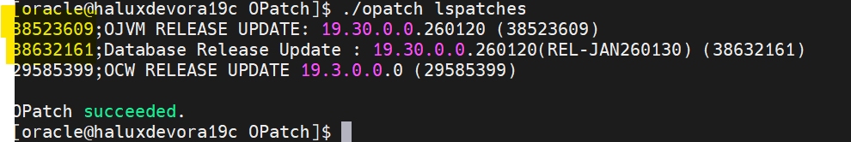
7. Post-Patch Activities (Post-QA)

7.1 Start Database
sqlplus / as sysdba
STARTUP;

7.2 Run Datapatch

cd $ORACLE_HOME/OPatch
./datapatch -verbose

✅ Ensure:
SQL Patching tool complete with no errors

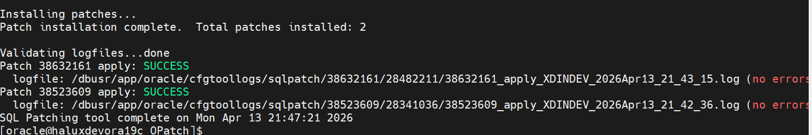

8. Post-QA Verification Checks
8.1 Post-QA: DBA_REGISTRY_SQLPATCH

SELECT patch_id, action, status, action_time
FROM dba_registry_sqlpatch
ORDER BY action_time;

✅ Patch action should show SUCCESS.

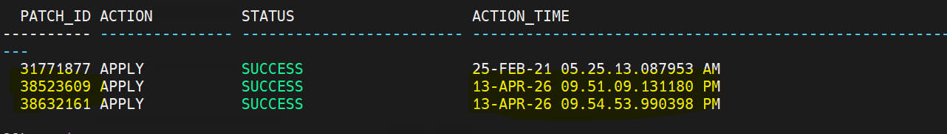

8.2 Post-QA: Component Validation

SELECT comp_name, status, version
FROM dba_registry;

✅ All components must be VALID.

8.3 Post-QA: Invalid Objects Check

set lines 200
col owner for a20
col object_name for a30
col object_type for a20

SELECT COUNT(*) AS invalid_objects
FROM dba_objects
WHERE status = 'INVALID';

select owner,object_name,object_type,status from dba_objects where status='INVALID' order by 1,3,2;

If invalid objects exist:

@?/rdbms/admin/utlrp.sql
Recheck invalid count.

8.4 Listener & Database Verification

ps -ef | grep pmon
ps -ef | grep tns – if listener is not showing start the listener.
lsnrctl start <listener name>
lsnrctl status <listener name>

9. Take POSTQA of database & Validate Services
9.1 Take PostQa after patching.
Sqlplus / as sysdba
Spool <ctask>postqa.log
@dbpreqa.sql
Spool off
9.2 Validate services.
Run these to confirm everything is healthy:
Ps -ef | grep pmon
ps -ef | grep tns
lsnrctl status <listener name>
tnsping <dbname>
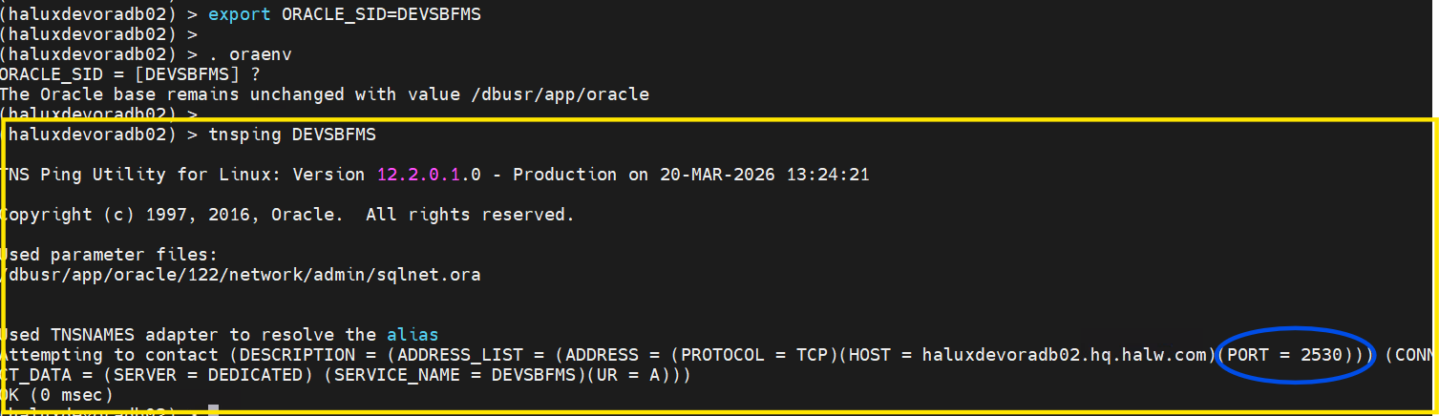
Also check the Remote connectivity
sqlplus system@dbname
It will prompt to enter the password, enter the password.
If it connected without and error and show user will give you user is “SYSTEM”. It means remote connectivity is successful.
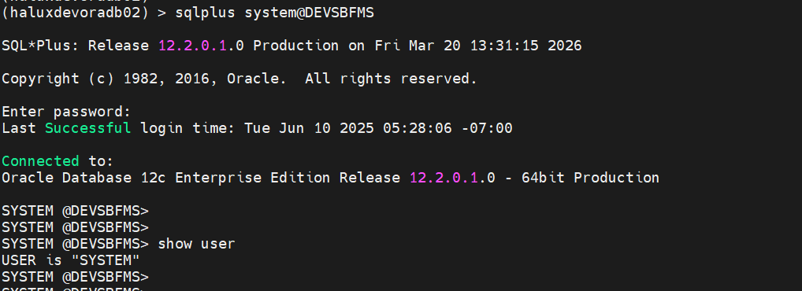

Or else you can also check using Sql developer.
Open sql developer.
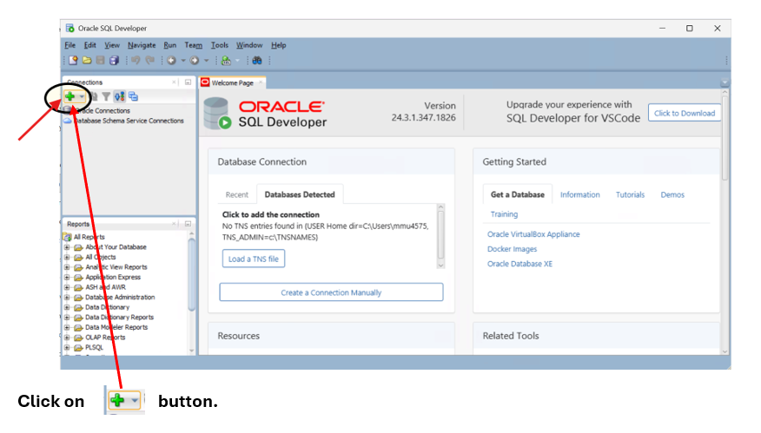
Input all details as mentioned in screen shot. You will find all these details in Tnsping
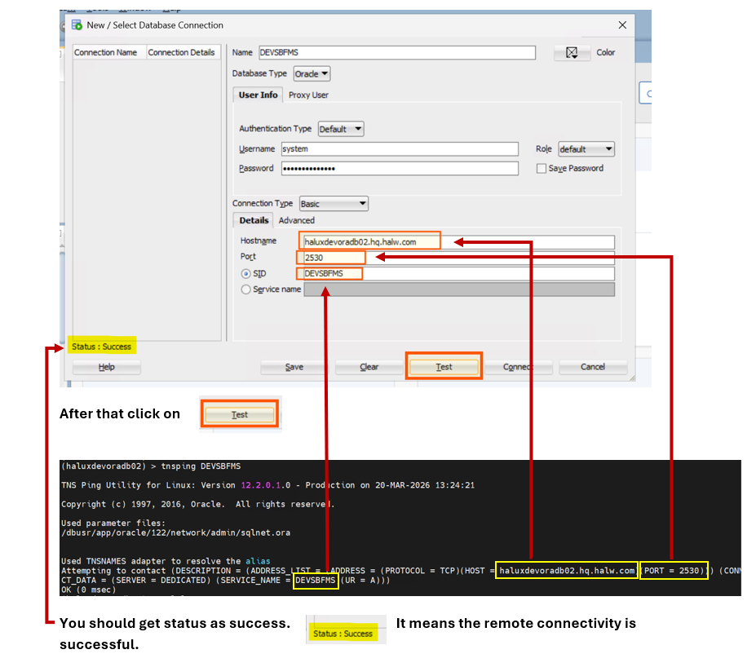

10. Rollback Procedure (If Required)

10.1 Rollback Patch from Oracle Home

Cd $ORACLE_HOME/OPatch
opatch rollback -id <patch_number>

10.2 Run Datapatch

cd $ORACLE_HOME/OPatch
./datapatch -verbose

